Herramienta de partes vinculadas consejeros
Cambios mayo 2026

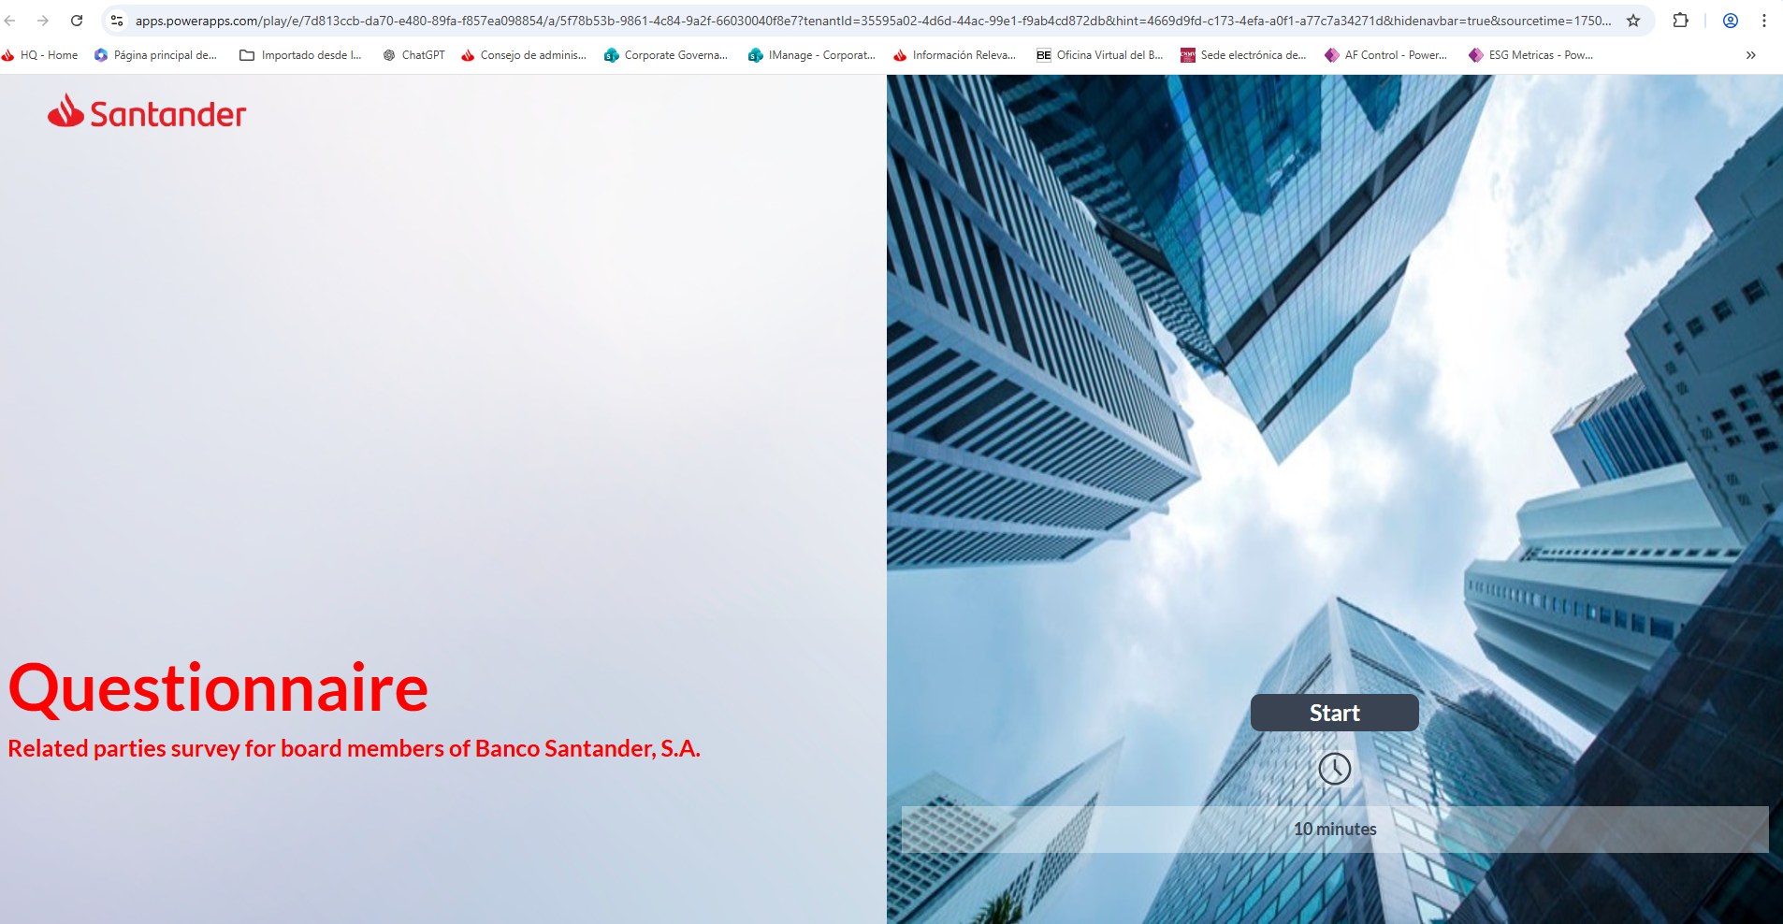

Portada:
- Cambiar la foto para evitar confusión con la herramienta de reevaluación anual
- Cambiar el texto de la portada por “Related parties questionnaire for Banco Santander S.A. board members”

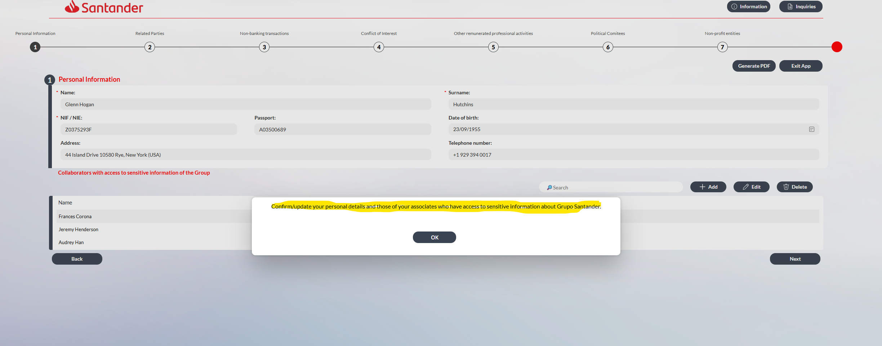

Ventana emergente:
- Cambiar el texto por:
  - Para todos los cuestionarios de consejeros, tanto ejecutivos como no ejecutivos, actualizar el siguiente texto: Please confirm or update your personal information, as appropriate.
  - Para los cuestionarios de los consejeros no ejecutivos, además del texto anterior, incluir el siguiente párrafo tras un punto y aparte: Please provide or confirm, as appropriate, the personal information of any assistants who have access to confidential information about Grupo Santander.

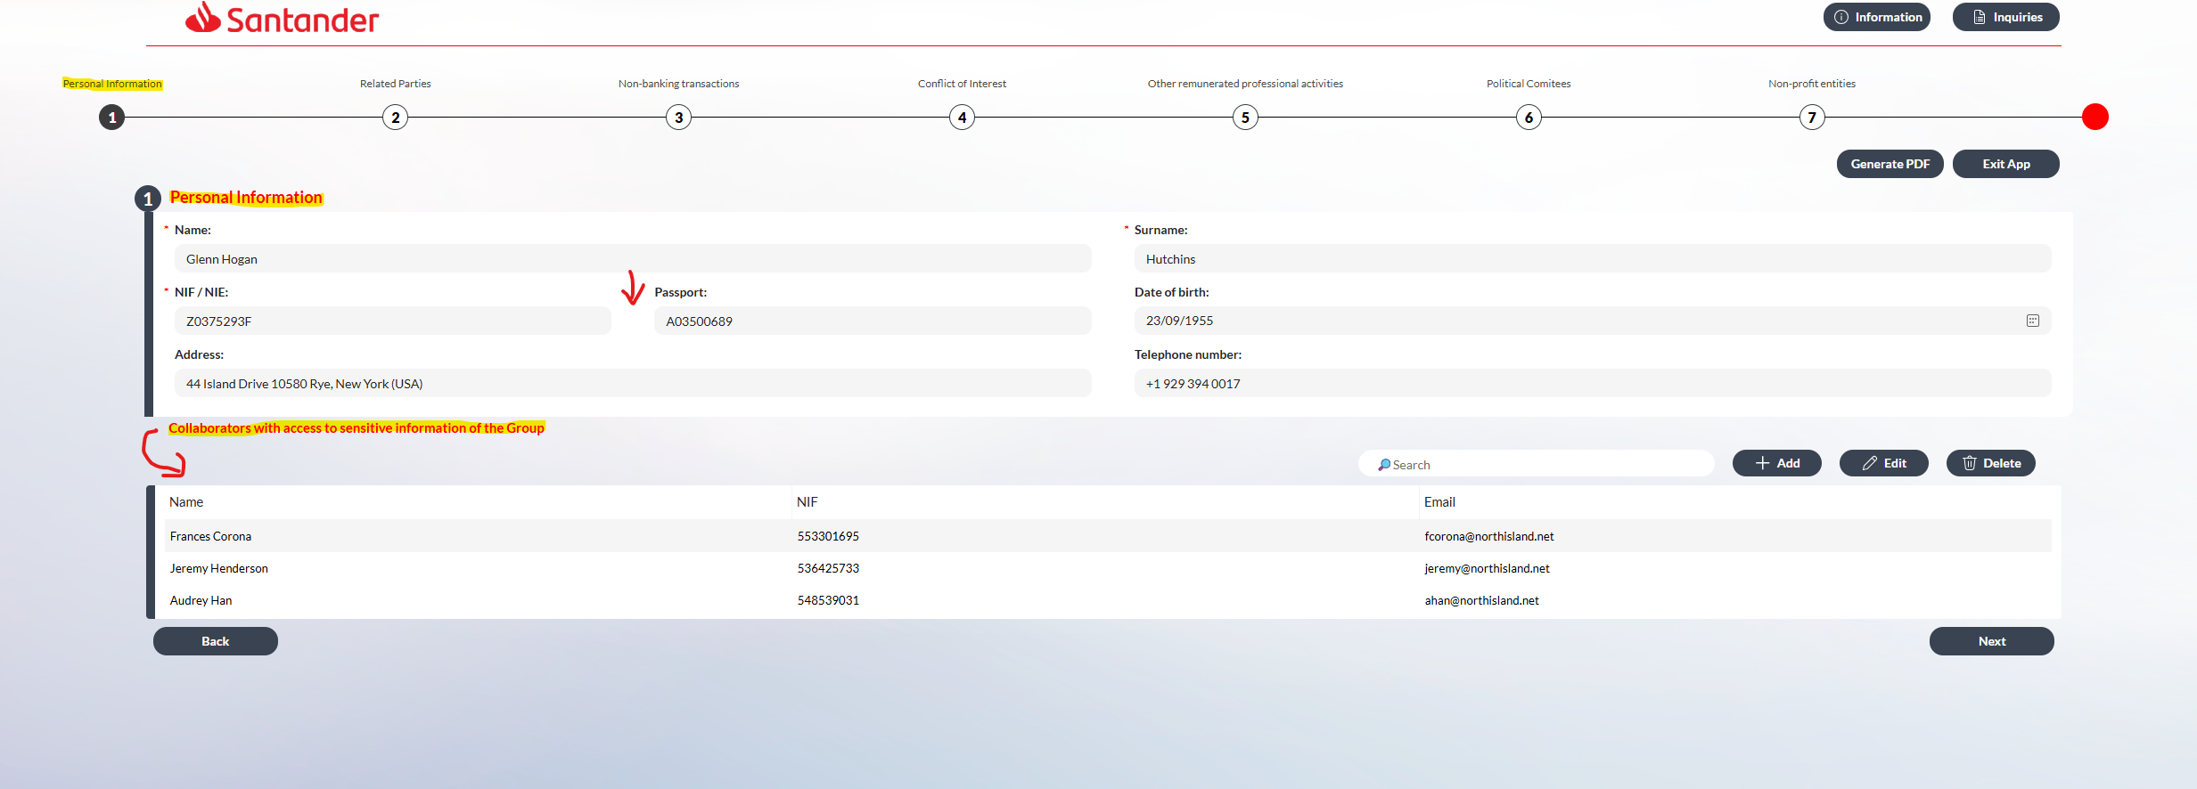
Pantalla 1:
- Sustituir “Personal information” por “Director’s personal information”.
- En esta pantalla inicial sustituir “NIF/NIE” por “Spanish ID number (NIF for Spanish directors / NIE for non-Spanish directors)”.
- Entre ese campo y el de “Passport”, donde marco con una flecha roja, incluir un nuevo campo para el número de identificación del país de residencia, que se titule “National ID number (non-Spanish directors only) (in case of US directors, please include US SSN)”.
- La frase “Collaborators with access to sensitive information of the Group” hay que bajarla para que esté justo encima del siguiente cuadro y hay sustituir el texto por “Personal information of the director’s assistants with access to confidential information about Grupo Santander”.

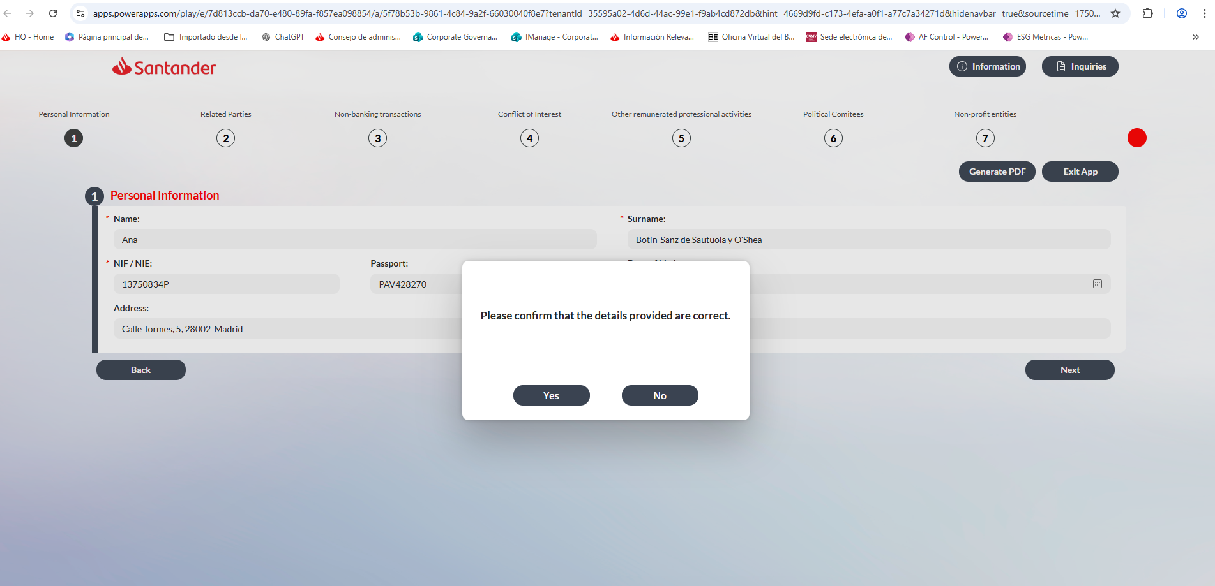

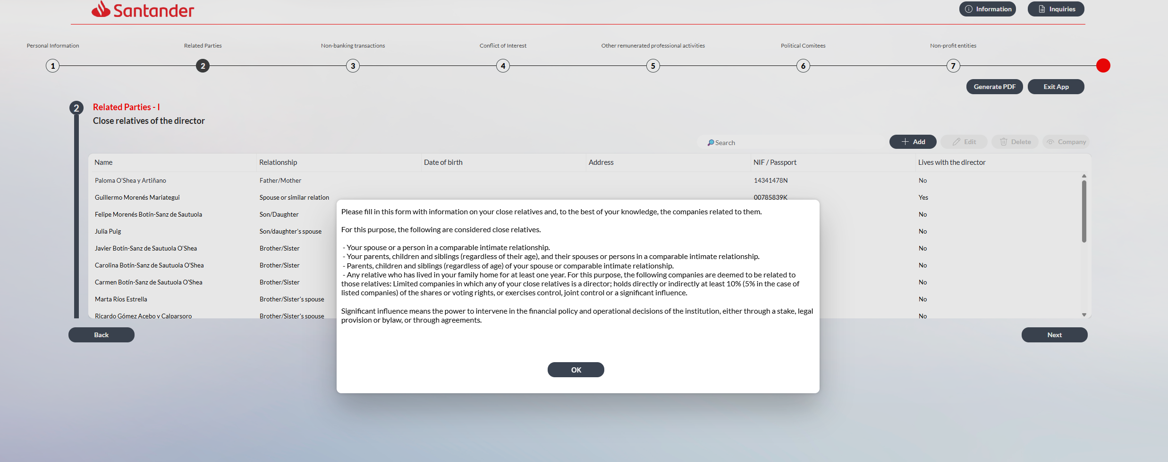

Ventana emergente:
- Sustituir el texto por este:
“Please fill in, to the best of your knowledge, the information on your close relatives and the entities related to them. For these purposes:
- The following are considered close relatives:
- your spouse or a person in a comparable intimate relationship (hereinafter “equivalent”);
- your children, parents and siblings;
- the children, parents and siblings of your spouse or equivalent;
- the spouses or persons in a comparable intimate relationship of all the individuals listed above;
- your grandchildren;
- persons dependent on you, or dependent on your spouse or equivalent;
- any other relative who you may influence, or who may influence you, in their/your relationship with the entity; and
- any other relative with whom you have lived for at least the past year.”

- The following entities are deemed to be related to those relatives:
Companies, trusts or associations:
- in which any of your close relatives:
- is a director or holds another managerial position;
- holds directly or indirectly at least 10% (5% in the case of listed companies) of the shares or voting rights;
- exercises control, joint control or a significant influence (meaning the power to intervene in the financial policy and operational decisions of the institution, either through a stake, legal provision or bylaw, or through agreements); or
- that have been established for the benefit of your close relative, or whose economic interests are substantially equivalent to those of your close relative.”

- When asked about conflicts of interest, please indicate whether you believe any of the declared companies may give rise to a conflict due to their relationship with Grupo Santander, whether as clients, suppliers, or in a similar capacity.

- The following terms shall have the meanings set out below:
- Listed company means a company whose shares are publicly traded on a stock exchange.
- Asset-holding company means a company whose activity is limited to the holding of assets and does not carry out any economic activity.
- Other companies means any commercial company other than a listed company or an asset-holding company, as well as any trust or association.

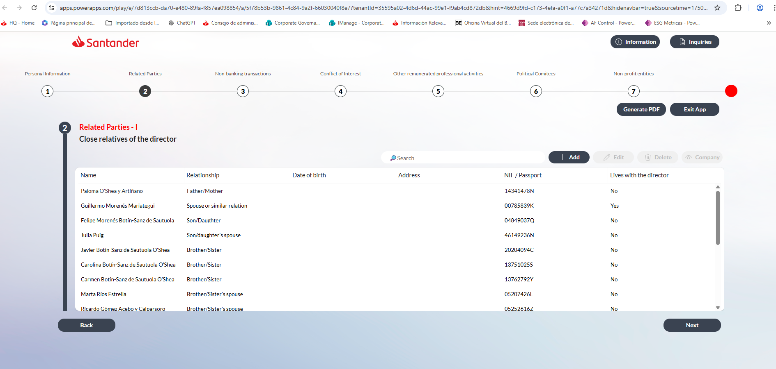
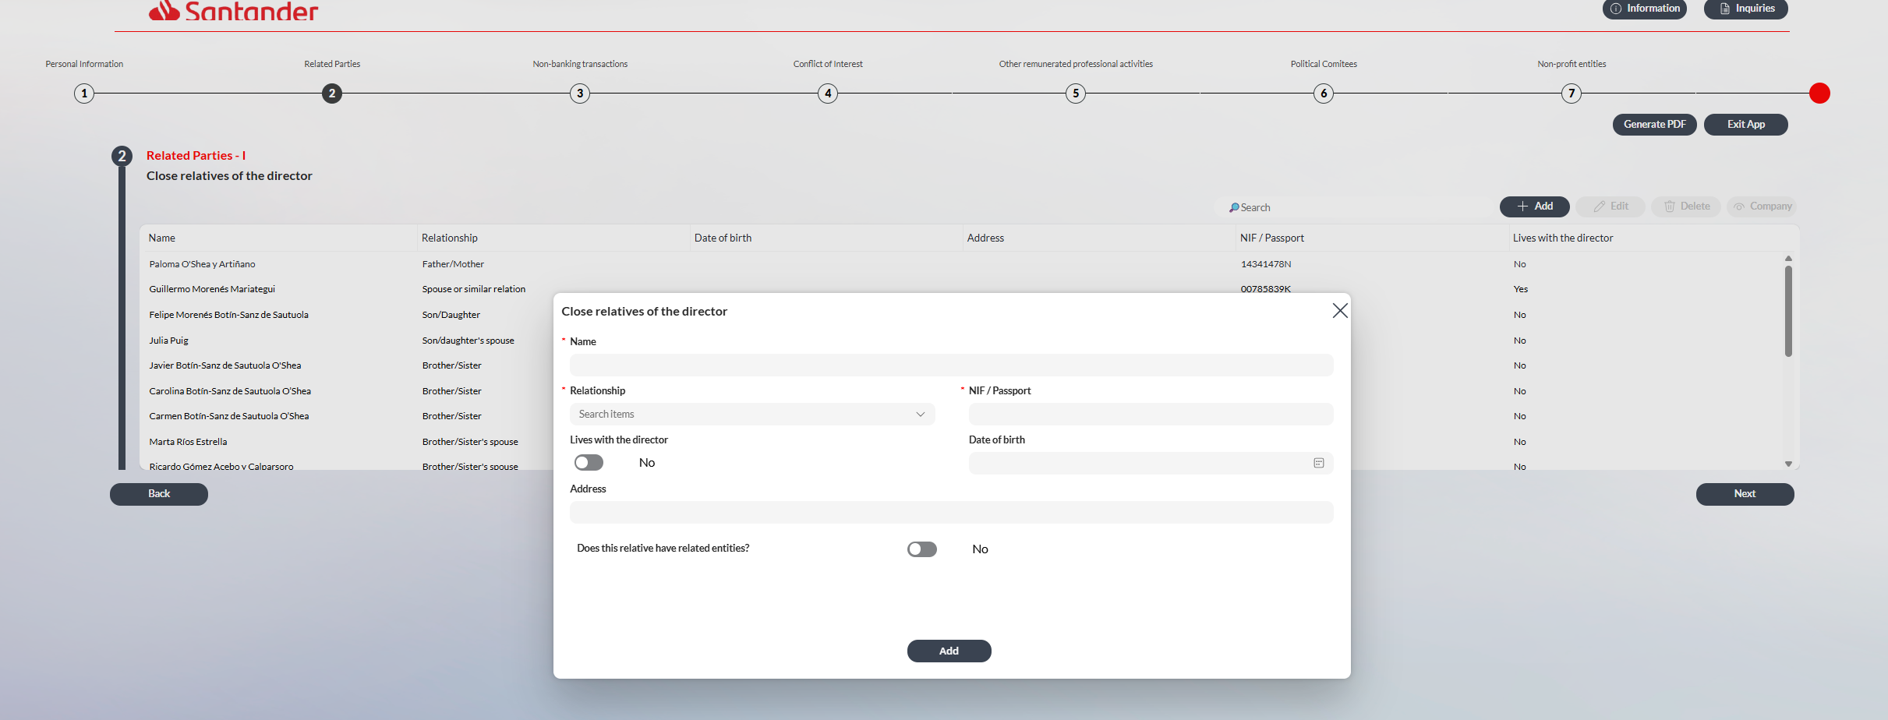

- Sustituir en el desplegable de familiares el texto “Spouse or similar relation” por “Spouse or equivalent”.

- Actualizar el desplegable de familiares para incluir nuevas categorías:
  - Spouse’s child’s spouse
  - Spouse’s parent’s spouse
  - Spouse’s sibling’s spouse
  - Dependant

- Añadir después de “NIF / Passport” otro campo que sea “National ID number (non-Spanish directors only) (in case of US directors, please include US SSN)”.

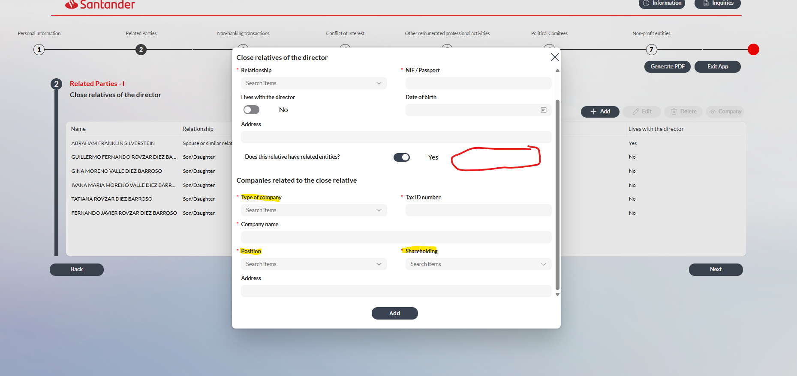
- Actualizar desplegable de position: el texto Senior manager por Managerial position.

- Actualizar el desplegable de Type of company para actualizar el nombre de las siguientes categorías:
  - Cambiar “Commercial” por “Other companies”.
  - Cambiar “Listed” por “Listed company”.
  - Cambiar “Holding” por “Asset-holding company”.

- Actualizar el texto de los desplegables de shareholding:
  - Eliminar “Exercise significant influence.

  - No tocar el desplegable del “≥10%”, pero el de “< 10% or no participation” sustituirlo por “From 1% to 9.99%”
  - En el caso de Listed no tocar “≥5%”, pero el de “< 5% or no participation” sustituirlo por “From 1% to 4.99%”.
  - Añadir nuevo porcentaje en todas las opciones de compañías con el siguiente texto: “<1% or no ownership interest”

- Crear nuevos campos de respueta yes/no
  - Control or joint control or significant influence
  - Established for his/her benefit / common interests
  - Conflict of interests

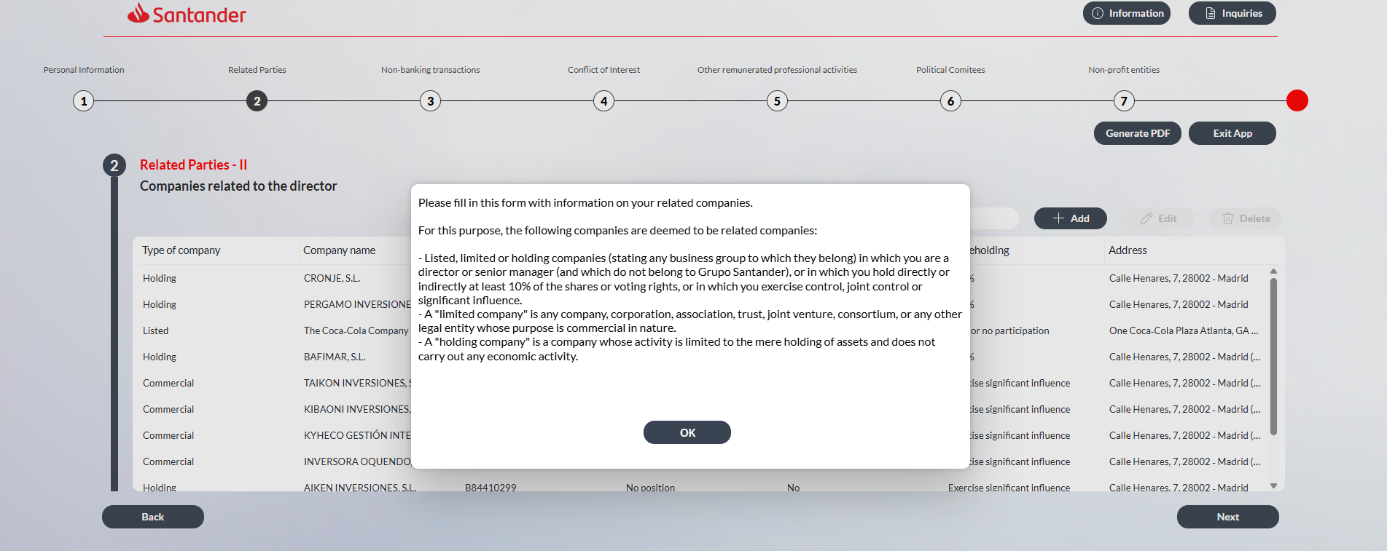
Ventana emergente
“Please fill in the information on your related entities. For these purposes:
- The following entities are deemed to be related to those relatives:
Companies, trusts or associations:
- in which you:
- are a director or hold another managerial position;
- hold directly or indirectly at least 10% of the shares or voting rights;
- exercise control, joint control or a significant influence (meaning the power to intervene in the financial policy and operational decisions of the institution, either through a stake, legal provision or bylaw, or through agreements); or
- that have been established for your benefit, or whose economic interests are substantially equivalent to yours.”

- When asked about conflicts of interest, please indicate whether you believe any of the declared companies may give rise to a conflict due to their relationship with Grupo Santander, whether as clients, suppliers, or in a similar capacity.

- The following terms shall have the meanings set out below:
- Listed company means a company whose shares are publicly traded on a stock exchange.
- Asset-holding company means a company whose activity is limited to the holding of assets and does not carry out any economic activity.
- Other companies means any commercial company other than a listed company or an asset-holding company, as well as any trust or association.

La referencia a trusts or associations podría eliminarse de aquí para los consejeros porque más adelante hay una pantalla de non-profit entities.

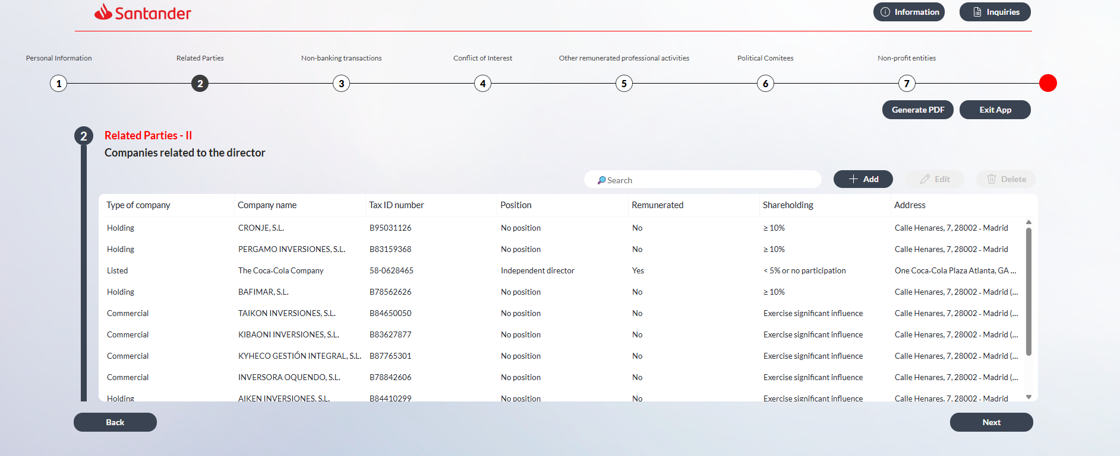
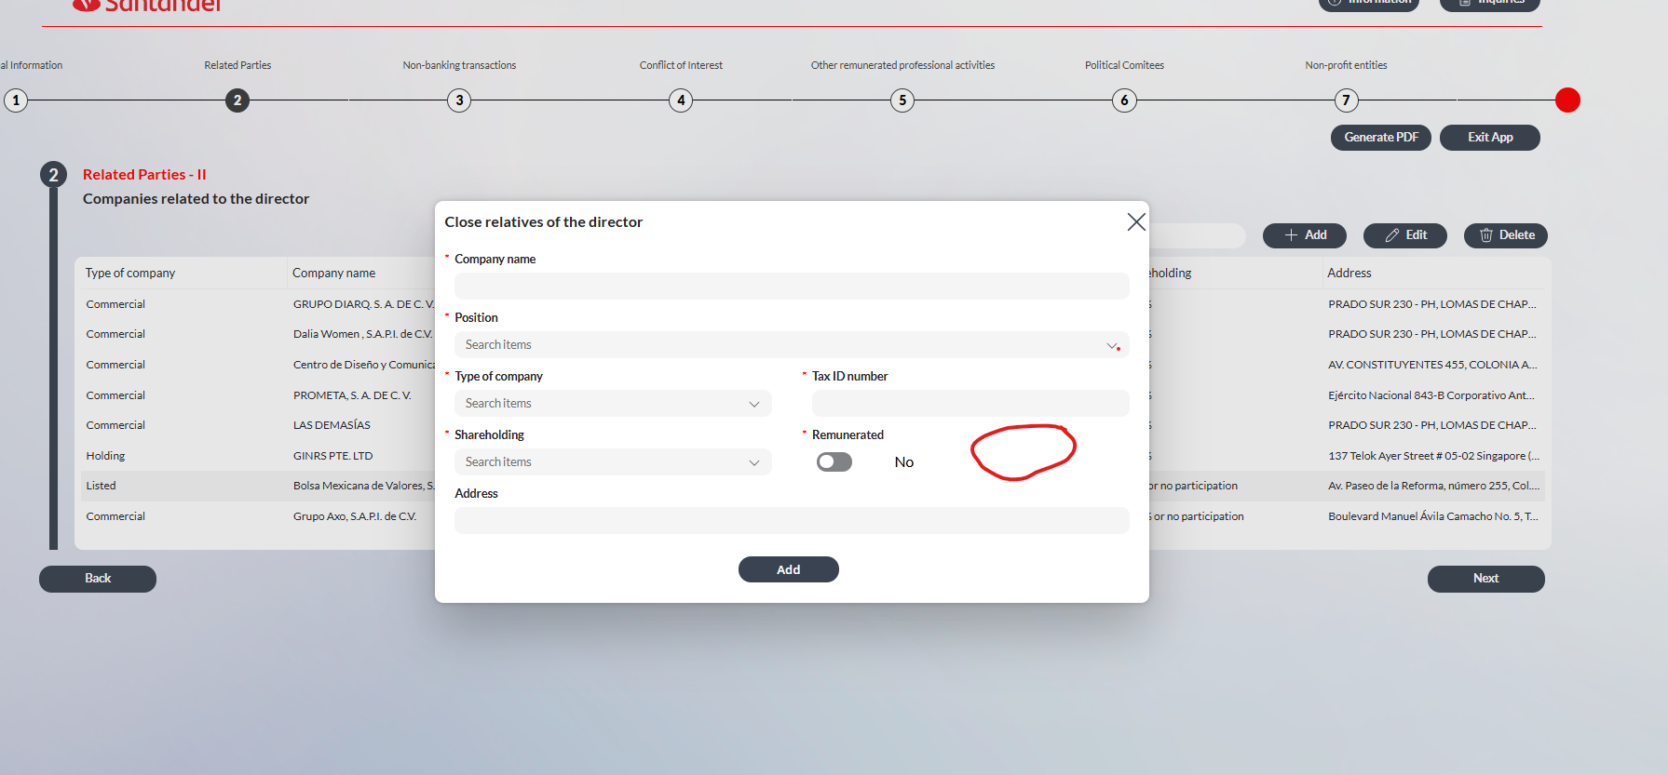
- Sustituir en el desplegable de familiares el texto “Spouse or similar relation” por “Spouse or equivalent”.

- Actualizar el desplegable de Type of company para actualizar el nombre de las siguientes categorías:
  - Cambiar “Commercial” por “Other companies”.
  - Cambiar “Listed” por “Listed company”.
  - Cambiar “Holding” por “Asset-holding company”.

- Actualizar el texto de los desplegables de shareholding:
  - Eliminar “Exercise significant influence”.
  - No tocar el desplegable del “≥10%”, pero el de “< 10% or no participation” sustituirlo por “From 1% to 9.99%”

  - En el caso de Listed poner los mismos porcentajes que los otros tipos de compañía, es decir, cambiar el 5% por el 10%.

  - Añadir nuevo porcentaje en todas las opciones de compañías con el siguiente texto: “<1% or no ownership interest”

- Crear nuevos campos de respueta yes/no
  - Control or joint control or significant influence
  - Established for his/her benefit / common interests
  - Conflict of interests

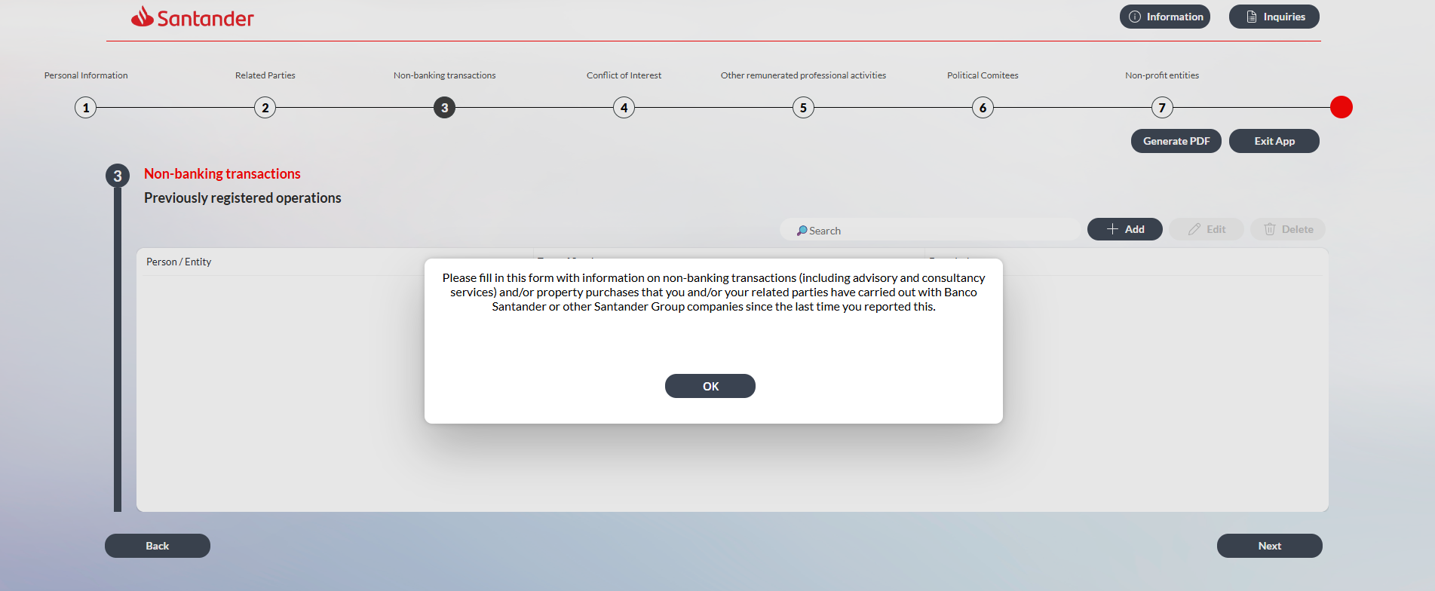
Ventana emergente
- Cambiar texto por “Please fill in/update the information on non-banking transactions (including advisory and consultancy services) and/or property purchases that you and/or your related parties have carried out with Banco Santander or other Santander Group companies”.
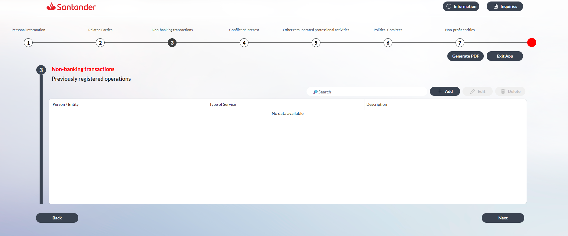
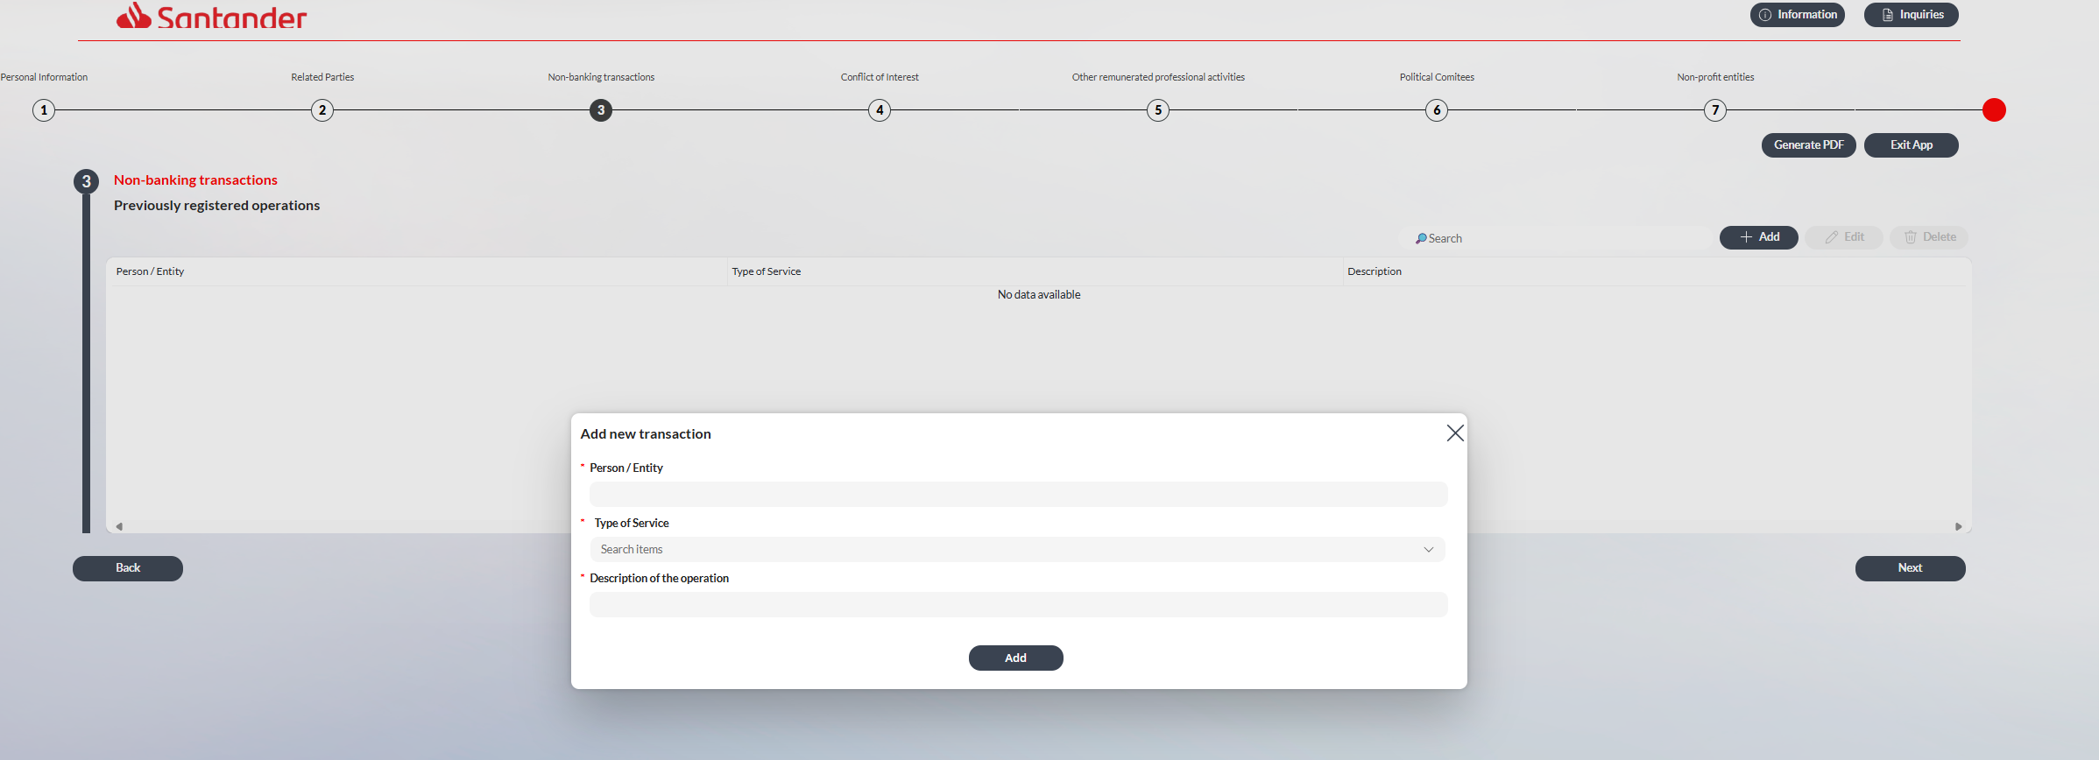
Desplegables “Type of Service” (poner “service” en minúscula):
- Eliminar “Leasing”.
- Cambiar “Counseling / Consulting” por “Consulting services”.
- Cambiar “Provision of services” por “Other services”.
- Cambiar “Others” por “Other transactions”.
- Cambiar “Description of the operation” por “Description of the transaction”.
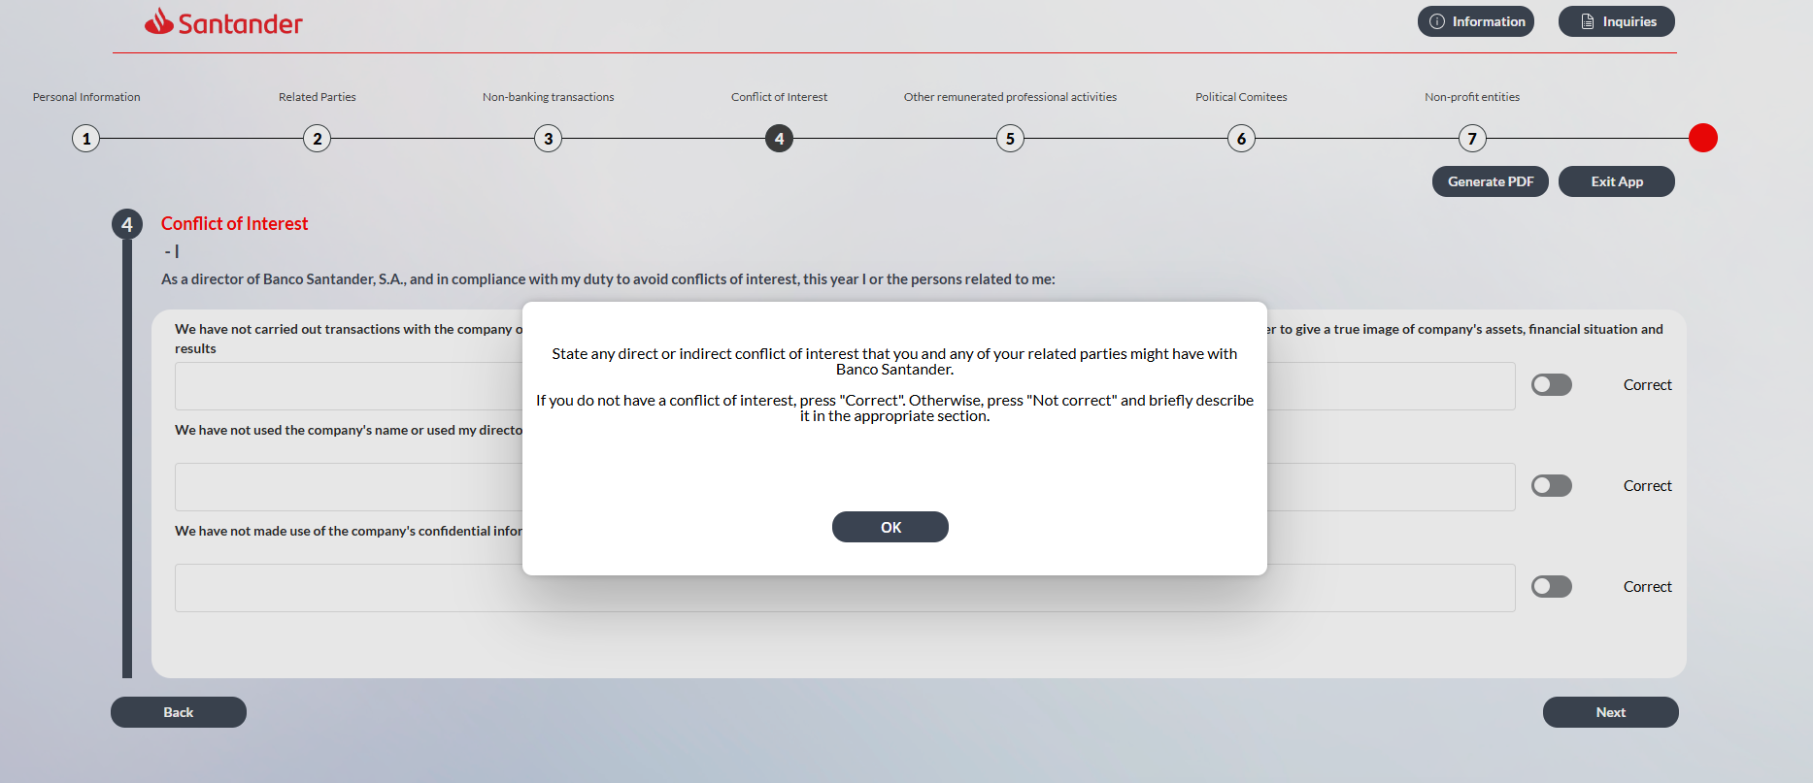

Ventana emergente
“Please state any actual or potential direct or indirect conflicts of interest that you or any of your related parties may have with Banco Santander, S.A.
If you do not have any conflict of interest, select ‘Correct’. Otherwise, select ‘Not correct’ and briefly describe it in the relevant section.”

Pantallazos

Conflict of Interest
- I
Texto anterior:
As a director of Banco Santander, S.A., and in compliance with my duty to avoid conflicts of interest, this year I or the persons related to me:
We have not carried out transactions with the company other than ordinary transactions under standard conditions and of minor importance that do not need to be reported in order to give a true image of company's assets, financial situation and results
We have not used the company's name or used my director status to exert undue influence on private transactions
We have not made use of the company's confidential information and other business assets for private purposes
Nueva propuesta:
As a director of Banco Santander, S.A., and in compliance with my duty to avoid conflicts of interest, I hereby confirm that, during the last half-year (whether the first or second half of the year, as applicable), neither I nor any persons related to me have:
- entered into transactions with the company other than ordinary-course transactions conducted on standard terms and of minor significance, which do not require disclosure in order to present a true and fair view of the company’s assets, financial position, and results;
- used the company’s name or my position as Director to exert undue influence in private transactions; and/or
- made use of the company’s confidential information or other business assets for personal purposes.

Conflict of Interest
- II
Texto anterior:
As a director of Banco Santander, S.A., and in compliance with my duty to avoid conflicts of interest, this year I or the persons related to me:
We have not taken advantage of the company's business opportunities
We have not received from third parties outside the company or its group any benefits or remuneration other than acts of mere courtesy in connection with my work
We have not carried out activities, of our own accord or for another person, that momentarily or potentially entail effective competition with the company or would otherwise place me in permanent conflict with the company's interests
Nueva propuesta:
As a director of Banco Santander, S.A., and in compliance with my duty to avoid conflicts of interest, I hereby confirm that during this year neither I nor any persons related to me have:
- taken advantage of the company’s business opportunities;
- received from third parties outside the company or its Group any benefits or remuneration, other than customary courtesies, in connection with my duties; and/or
- engaged, on my/their own behalf or on behalf of others, in any activities that involve actual or potential competition with the company, or that otherwise place me in a situation of ongoing conflict with the company’s interests.

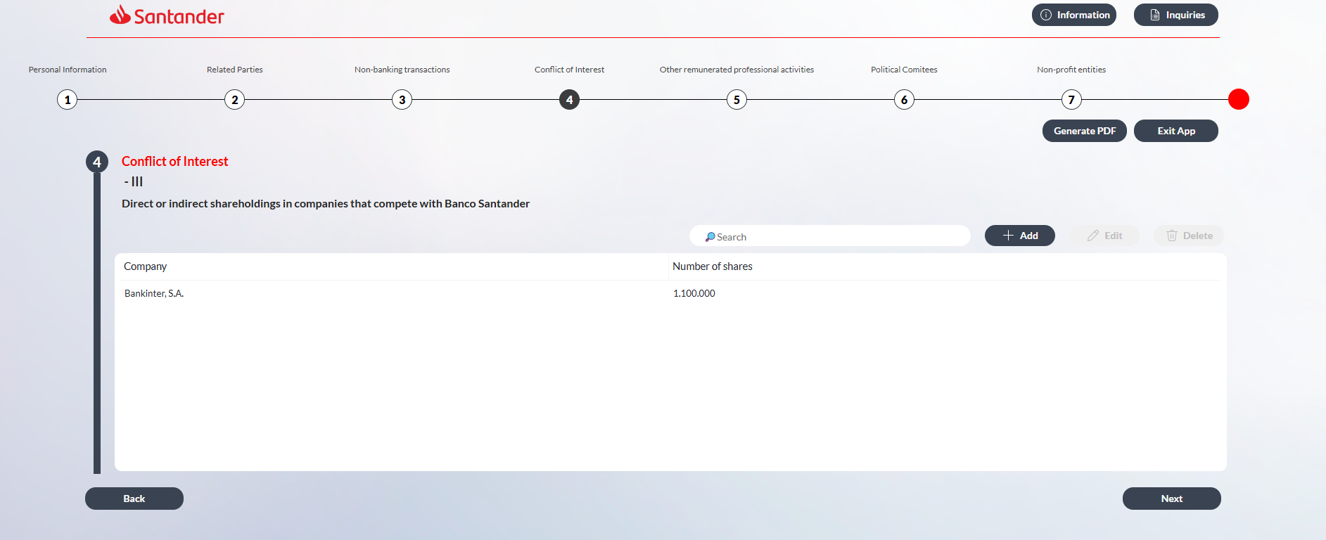

Ventana emergente conflictos de interés III
Texto anterior:
State the direct or indirect shareholding that you and your related persons have in companies that effectively compete with Banco Santander.
Nueva propuesta:
Please state any direct or indirect shareholdings that you or your related parties hold in companies that compete with Banco Santander, S.A.

Conflict of Interest
- III
Texto anterior:
Direct or indirect shareholdings in companies that compete with Banco Santander
Nueva propuesta:
Direct or indirect shareholdings in companies that compete with Banco Santander, S.A.

Suspendemos esta petición condicionada a la posibilidad de crear nuevos campos de ys/no en personas jurídicas vinculadas a consejero o familiares de consejeros.

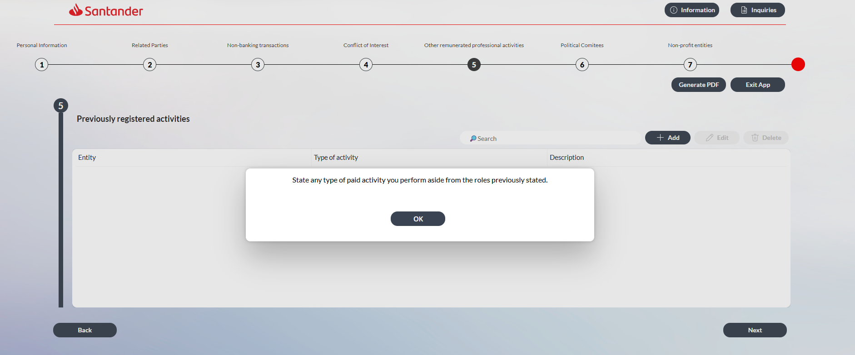
Ventana emergente:
- Cambiar el texto por: “Please state any remunerated activities you undertake in addition to the roles previously disclosed”.
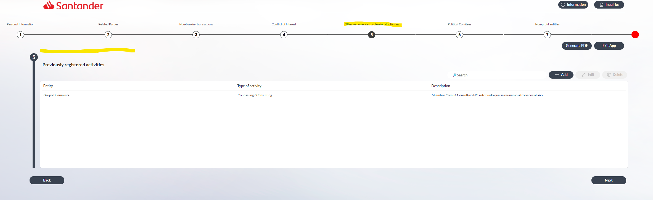
Poner el título que marco en amarillo también en la parte izquierda en rojo (que he marco también en amarillo), como en los otros apartados anteriores.

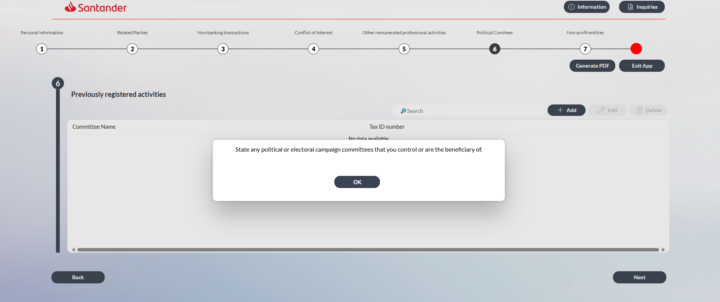
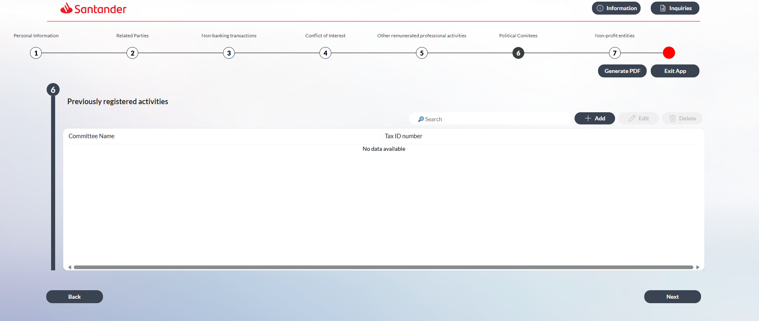
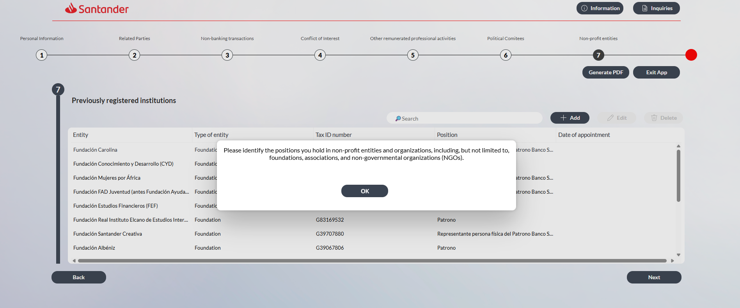
Ventana emergente:
- Cambiar el texto por: “Please provide details of any positions you hold in non-profit entities or organizations, including, but not limited to, foundations, associations, and non-governmental organizations (NGOs).”
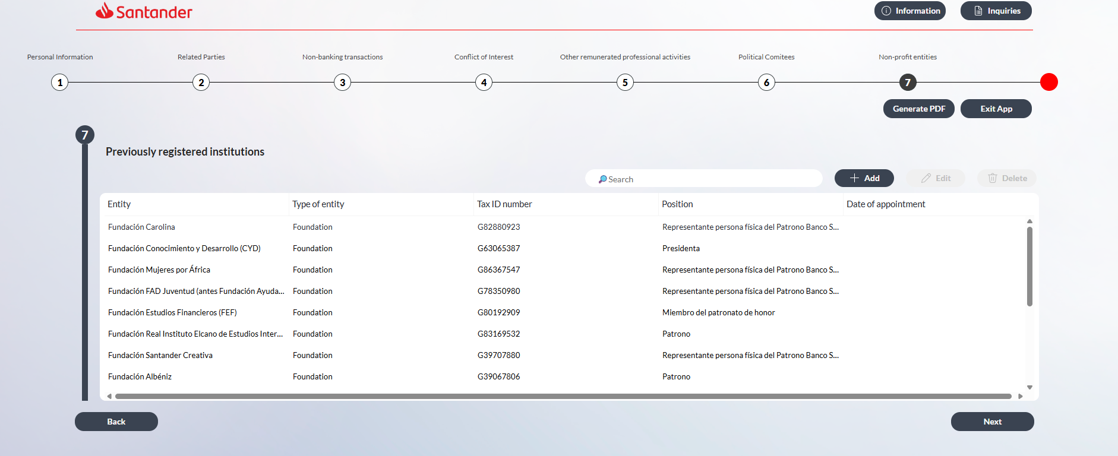
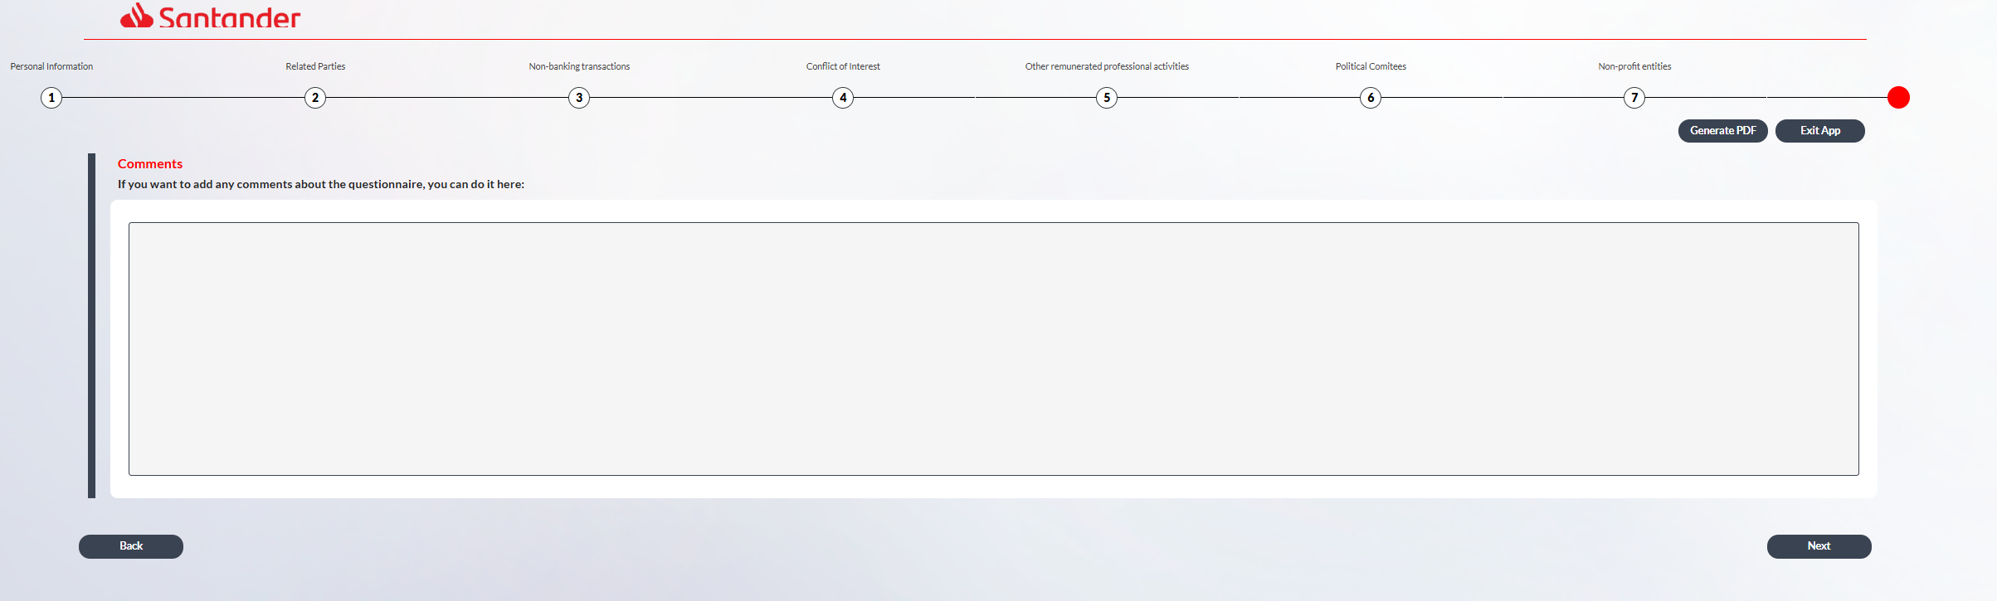
Pantalla:
- Cambiar el texto por: “If you wish to add any comments regarding the questionnaire, you may do so here:”
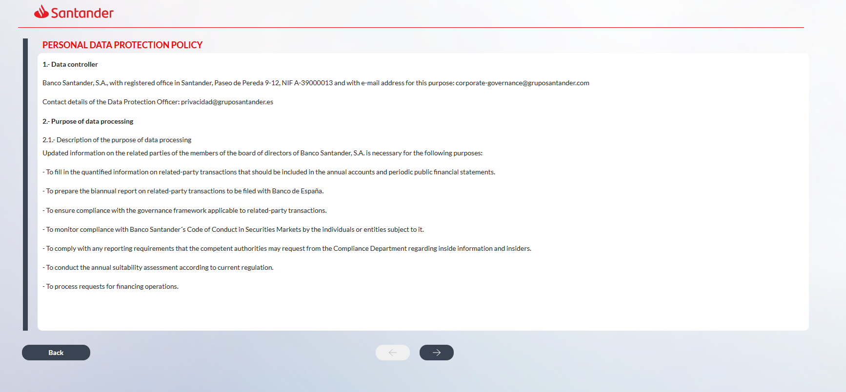
PERSONAL DATA PROTECTION POLICY
1.- Data controller
Banco Santander, S.A., with registered office at Paseo de Pereda 9-12, Santander, Spain, tax identification number (NIF) A-39000013, and e-mail address for these purposes: corporate-governance@gruposantander.com.
Contact details of the Data Protection Officer: privacidad@gruposantander.es.
2.- Purpose of data processing
2.1.- Description of the purpose of data processing
Updated information on the related parties of members of the board of directors of Banco Santander, S.A. is required for the following purposes:
- to ensure compliance with the governance framework applicable to related-party transactions;
- to complete the quantified information on related-party transactions to be included in the annual financial statements and periodic public financial disclosures;
- to prepare the biannual report on related-party transactions to be submitted to Banco de España;
- to process requests for financing operations;
- to carry out the annual suitability assessment in accordance with applicable regulations;
- to monitor compliance with Banco Santander’s Code of Conduct in Securities Markets by the individuals or entities subject to it; and
- to comply with any reporting requirements that may be requested by the competent authorities from the Compliance function in relation to inside information and insiders.

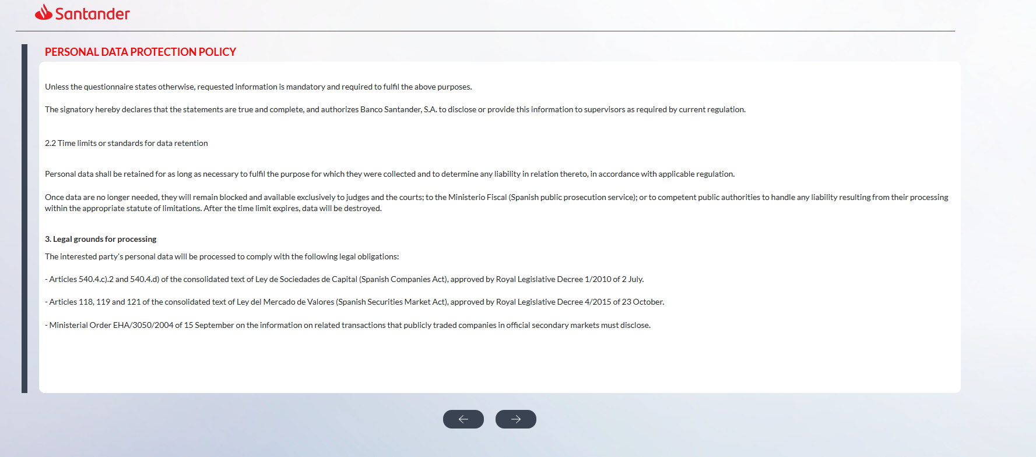

Unless otherwise indicated in the questionnaire, the requested information is mandatory and required to fulfil the purposes described above.
The signatory hereby declares that the information provided is true, accurate and complete, and authorizes Banco Santander, S.A. to disclose or provide this information to supervisors, as required under applicable regulations.
2.2 Data retention periods
Personal data shall be retained for as long as necessary to fulfil the purposes for which they were collected and to determine any potential liabilities arising therefrom, in accordance with applicable regulations.
Once the data are no longer necessary for these purposes, they will be blocked and made available only to judges and courts, the Ministerio Fiscal (Spanish public prosecutor’s office), or competent public authorities, for the purpose of addressing any potential liabilities arising from their processing within the applicable statutory limitation period. Upon expiry of such periods, the data will be deleted.
3. Legal grounds for processing Confirmar con Cumplimiento que las referencias normativas que les son aplicables no se han derogado y siguen vigentes
The personal data of the data subject will be processed in order to comply with the following legal obligations:
- Articles 540.4.c).2 and 540.4.d) of the consolidated text of the Ley de Sociedades de Capital (Spanish Companies Act), approved by Royal Legislative Decree 1/2010 of 2 July.
- Articles 118, 119 and 121 of the consolidated text of the Ley del Mercado de Valores (Spanish Securities Market Act), approved by Royal Legislative Decree 4/2015 of 23 October.
- Ministerial Order EHA/3050/2004, of 15 September, on the information on related transactions that publicly traded companies in official secondary markets must disclose.

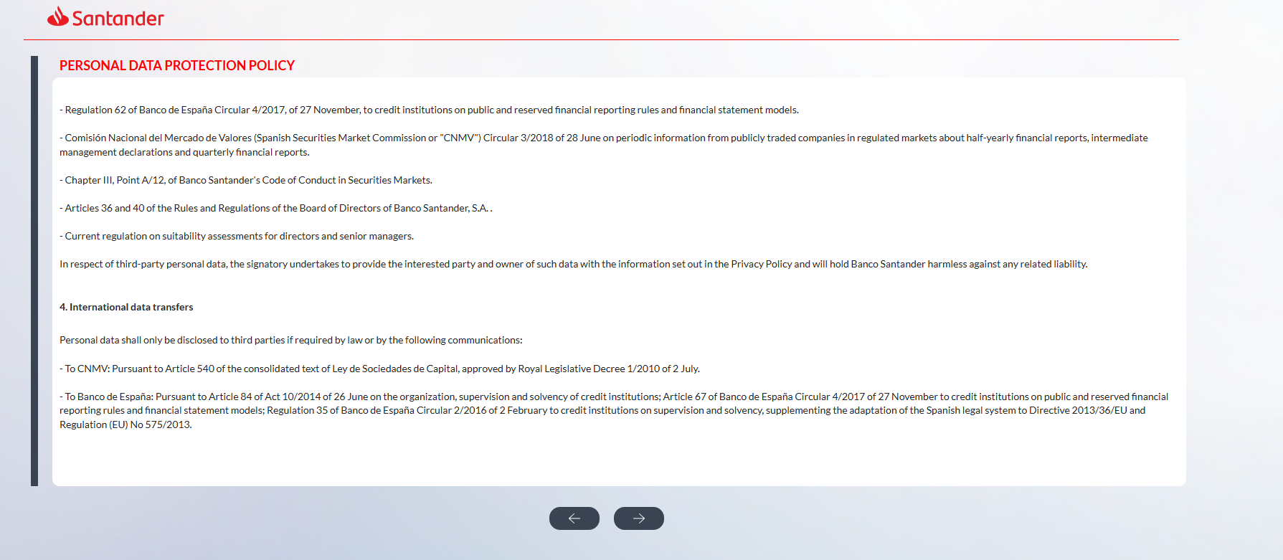
- Regulation 62 of Banco de España Circular 4/2017, of 27 November, to credit institutions on public and reserved financial reporting rules and financial statement models.
- Comisión Nacional del Mercado de Valores (Spanish Securities Market Commission or "CNMV") Circular 3/2018 of 28 June on periodic information from publicly traded companies in regulated markets about half-yearly financial reports, intermediate management declarations and quarterly financial reports.
- Chapter III, Point A/12, of Banco Santander's Code of Conduct in Securities Markets.
- Articles 36 and 40 of the Rules and Regulations of the Board of Directors of Banco Santander, S.A.
- Applicable regulations governing suitability assessments for directors and senior managers.
With respect to third-party personal data, the signatory undertakes to provide the interested party and owner of such data with the information set out in the Privacy Policy and will hold Banco Santander harmless against any liability arising in this regard.
4. International data transfers Confirmar con Cumplimiento que las referencias normativas que les son aplicables no se han derogado y siguen vigentes
Personal data will only be disclosed to third parties when required by law, including in the following cases:
- To CNMV: Pursuant to Article 540 of the consolidated text of Ley de Sociedades de Capital, approved by Royal Legislative Decree 1/2010 of 2 July.
- To Banco de España: Pursuant to Article 84 of Act 10/2014 of 26 June on the organization, supervision and solvency of credit institutions; Article 67 of Banco de España Circular 4/2017 of 27 November to credit institutions on public and reserved financial reporting rules and financial statement models; Regulation 35 of Banco de España Circular 2/2016 of 2 February to credit institutions on supervision and solvency, supplementing the adaptation of the Spanish legal system to Directive 2013/36/EU and Regulation (EU) No 575/2013.

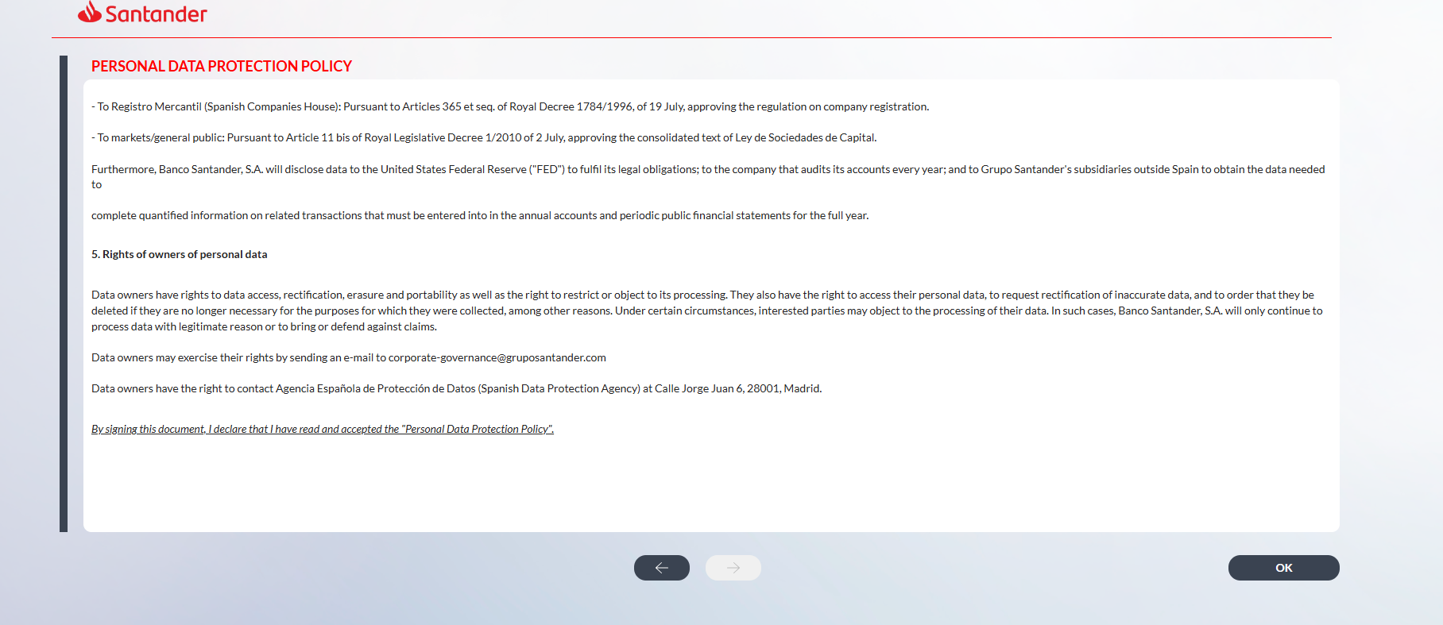
- To Registro Mercantil (Spanish Companies House): Pursuant to Articles 365 et seq. of Royal Decree 1784/1996, of 19 July, approving the regulation on company registration.
- To markets/general public: Pursuant to Article 11 bis of Royal Legislative Decree 1/2010 of 2 July, approving the consolidated text of Ley de Sociedades de Capital.
Furthermore, Banco Santander, S.A. will disclose personal data to the United States Federal Reserve ("FED") in order to fulfil its legal obligations; to the company that audits its financial statements each year; and to Grupo Santander's subsidiaries outside Spain, in order to obtain the information necessary to complete quantified information on related transactions that must be entered into in the annual financial statements and periodic public financial statements.
5. Rights of owners of personal data
Data owners have the right to access, rectify and erase their personal data, as well as the right to data portability and to request the restriction of, or to object to, its processing.
In particular, they have the right to request the rectification of inaccurate data or to the erasure of data where, among other reasons, it is no longer necessary for the purposes for which it was collected.
Under certain circumstances, interested parties may object to the processing of their data. In such cases, Banco Santander, S.A. will cease processing the data unless there are legitimate grounds for doing so of for the establishment, exercise or defence of legal claims.
Data owners may exercise their rights by sending an e-mail to corporate-governance@gruposantander.com.
Data owners also have the right to file a complaint with the Agencia Española de Protección de Datos (Spanish Data Protection Agency) located at Calle Jorge Juan 6, 28001 Madrid.
By signing this document, I declare that I have read and accepted the "Personal Data Protection Policy".

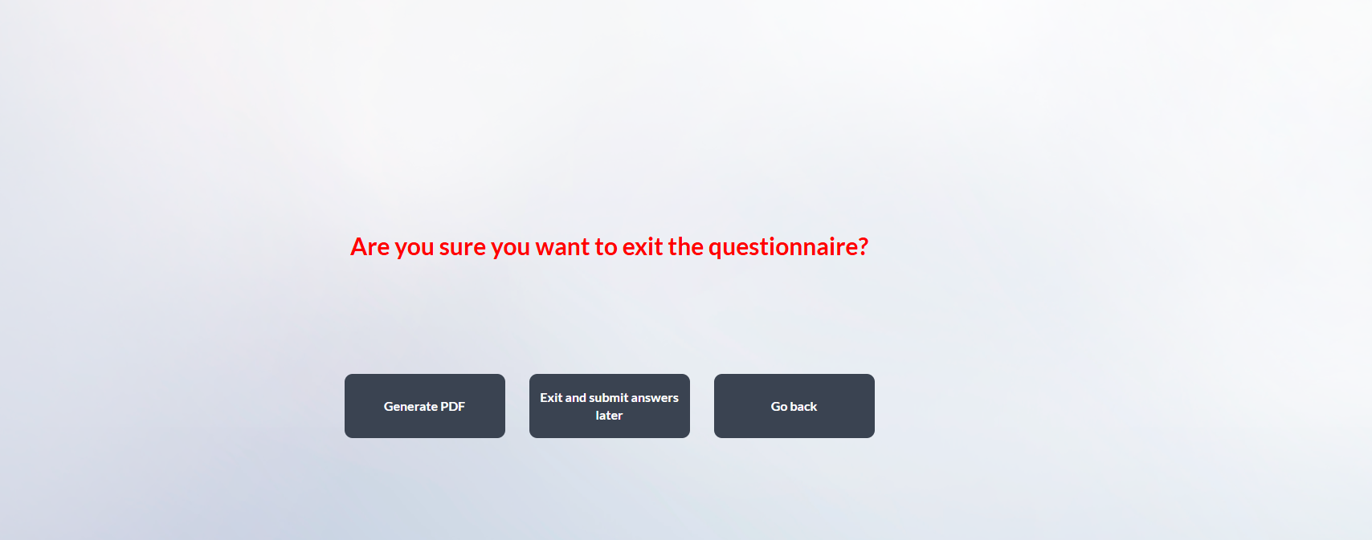

Textos de correos
- Inicio de campaña
Dear board member,
As part of our semi-annual process, Banco Santander is required to update information relating to directors' related-parties.
For this purpose, we kindly ask you to access the online application via the following link and review and update, where necessary, the information previously reported (please refer to the attached PDF). Once completed, the questionnaire must be signed and submitted through the application no later than XXday, XX June, 2026. Please find below a set of practical guidelines to assist you with this process.
Updating related-party information enables Banco Santander to comply with its corporate governance framework and applicable market abuse regulations, as well as to prevent and manage potential conflicts of interest. This information also supports the preparation of the related-party transactions note to the annual accounts, periodic public financial disclosures and the biannual report to Banco de España on outstanding financing transactions.
Should you have any questions, please do not hesitate to contact us at corporate-governance@gruposantander.com. For technical support, you may contact us by phone at +34 9128 97000 or by email at itsoportevip@gruposantander.com.
Thank you for your cooperation.
Legal Corporate Governance team
Questionnaire instructions:
- The information required for each section will be displayed in a window on the screen. It can also be accessed via the information icons located at the top left of the screen. Esto no lo veo en la herramienta, lo debieron eliminar cuando cambiaron la Plataforma, Habra que confirmarlo con Mozos.
- Please review all information, confirm that it is complete and up to date, or make changes where appropriate.
- To edit previously provided details, click the "Edit" button.
- To add new information, click the "Add" button.
- To confirm the information and proceed to the next screen, click the "Next" button.
- Once the questionnaire has been completed, click “Sign and send”. You will receive a confirmation e-mail including a PDF copy of the completed questionnaire.

- Recordatorio
Dear board member,
Please note that the deadline for completing the related parties questionnaire is XXday, XX June, 2026.
Please click on the following link to access the questionnaire and review and confirm or update the information.
Should you have any questions or require assistance, please do not hesitate to contact us at corporate-governance@gruposantander.com.
Thank you for your cooperation.
Legal Corporate Governance team

- Ultimátum
Dear board member,
Please note that the deadline for completing the related parties questionnaire is today.
Please click on the following link to access the questionnaire and review and confirm or update the information.
Should you have any questions or require assistance, please do not hesitate to contact us at corporate-governance@gruposantander.com.
Thank you for your cooperation.
Legal Corporate Governance team.
Por favor, cuando se firme el pdf, ya sea por el consejero o por su asistente, debe enviarse el mismo correo electrónico, que es este a continuación:

- Confirmación de firma de formulario consejero
Dear board member,
Please find attached a PDF document with the responses provided in the related parties questionnaire.
Thank you very much for your cooperation.
Legal Corporate Governance team

